1. **Write a program to read a text file and print the number of rows of data in the document.**

val text = sc.textFile("/home/acadgild/hadoop/Assign17_2.txt")

text.count()



1. **Write a program to read a text file and print the number of words in the document.**

val text = sc.textFile("/home/acadgild/hadoop/Assign17_2.txt")

val counts = text.flatMap(line => line.split(" "))

counts.count()

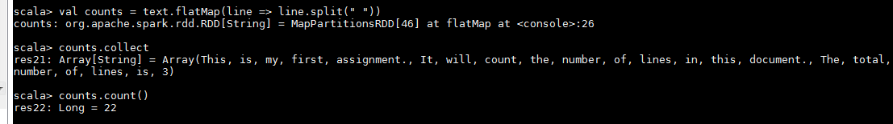

1. **We have a document where the word separator is -, instead of space. Write a spark code, to obtain the count of the total number of words present in the document.**

val text = sc.textFile("/home/acadgild/hadoop/Assign17_2_1.txt")

val counts = text.flatMap(line => line.split("-"))

counts.count()

